SAP BRP - ASN0000703
Current Version:
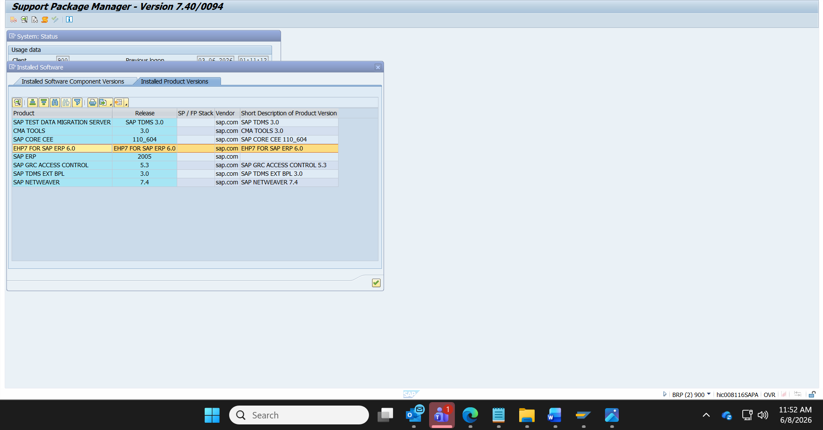
Last updated on:07-08-2015
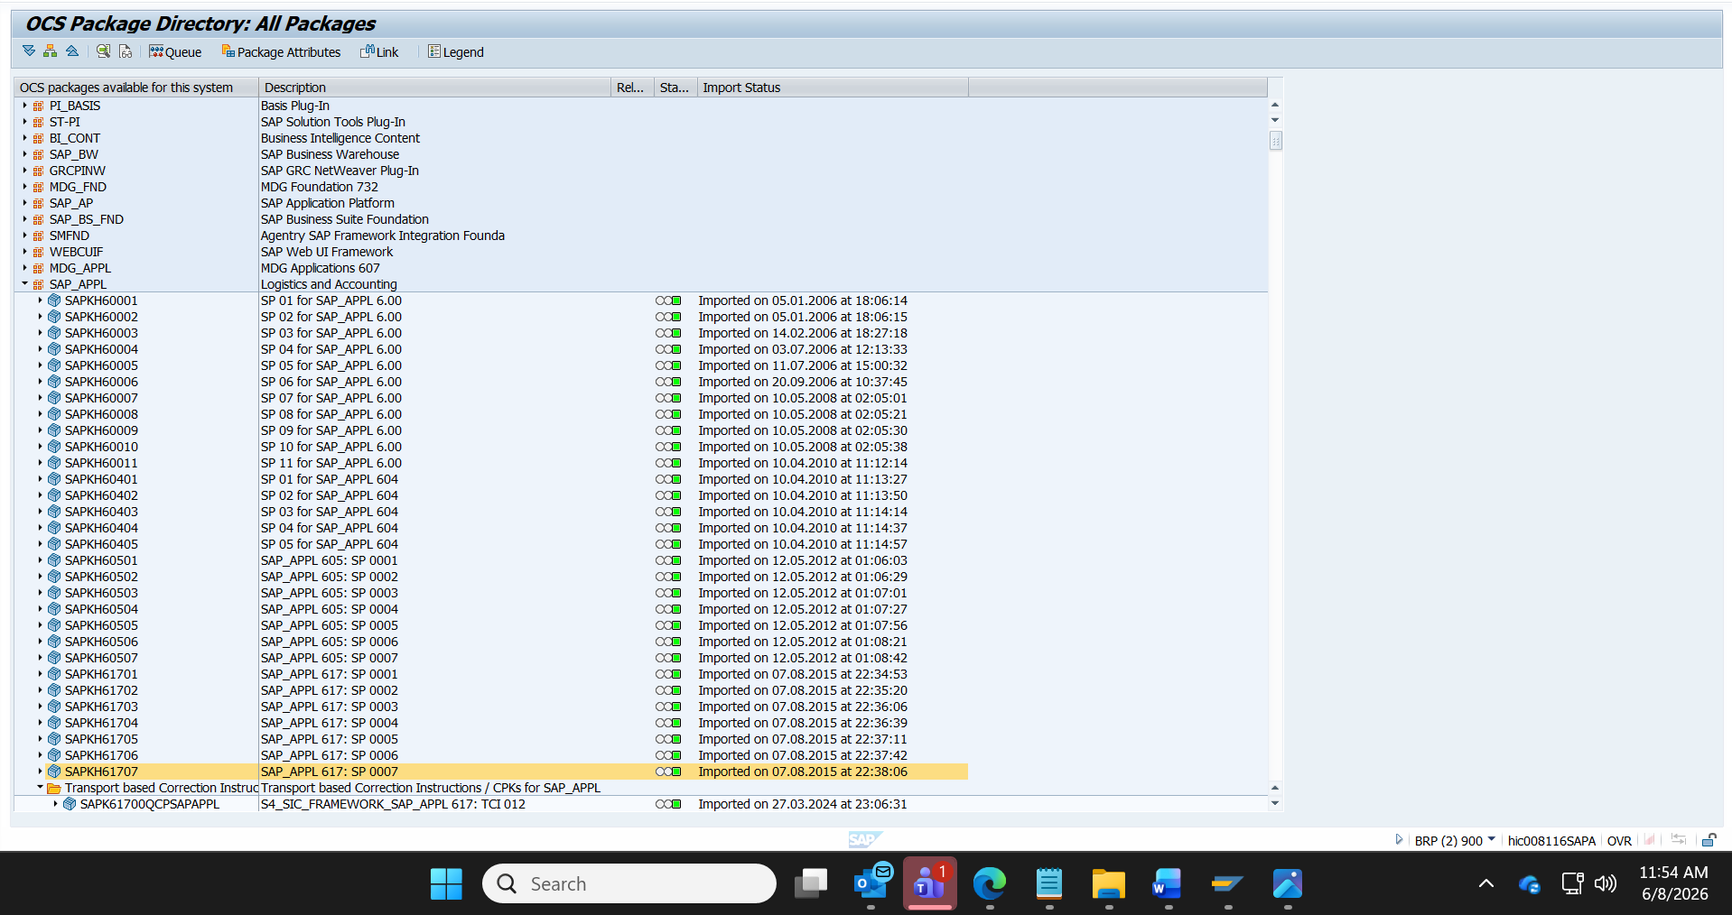
SAP Support End of Mainstream Maintenance:31.12.2027
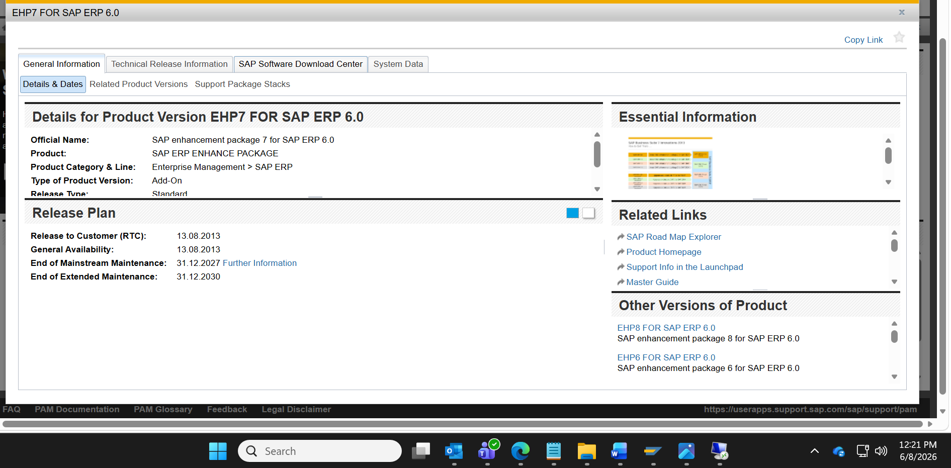

Latest patch available is 32:
